**Module 4: Python Project**

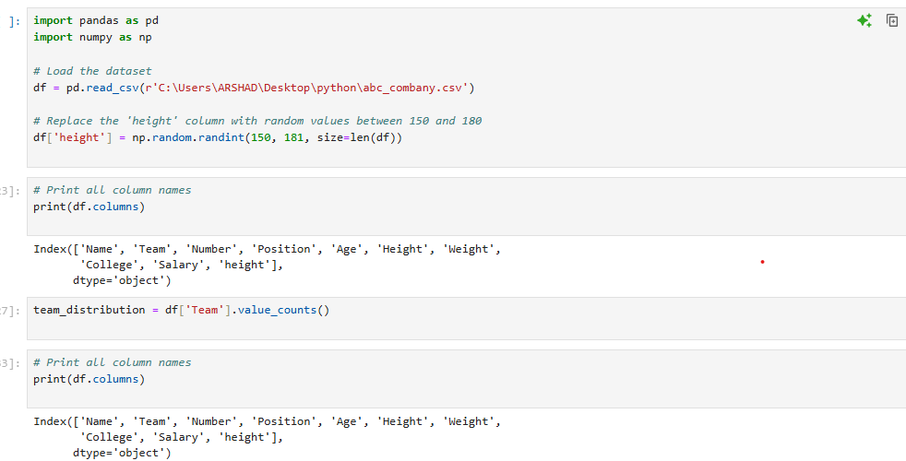

Preprocessing:  
Correct the data in the "height" column by replacing it with random numbers between 150 and 180. Ensure data consistency and integrity before proceeding with analysis. (1 mark)

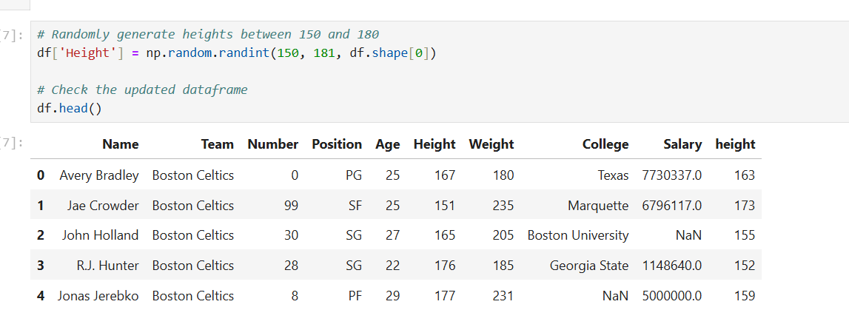

1. Determine the distribution of employees across each team and calculate the percentage split relative to the total number of employees. (2 marks)

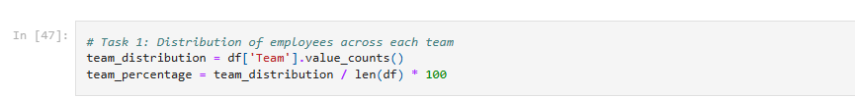

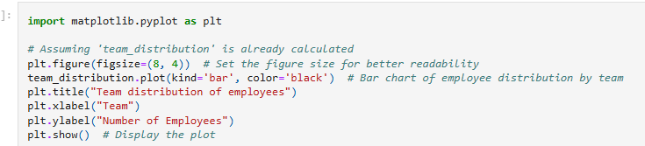

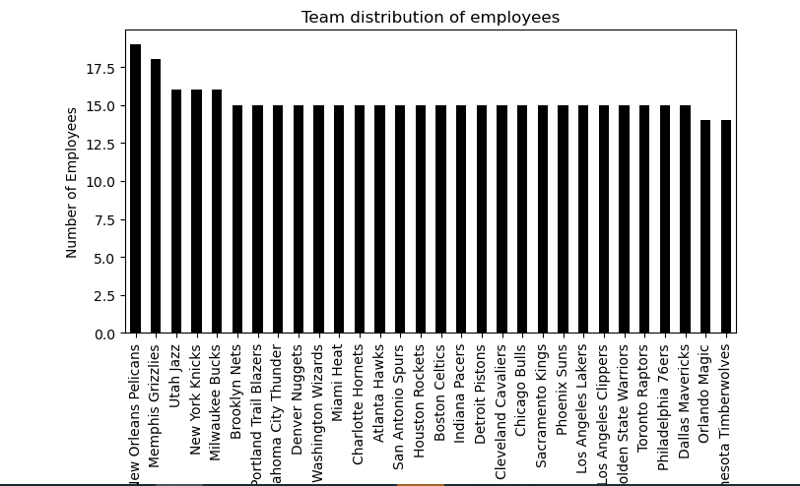

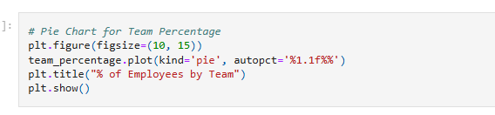

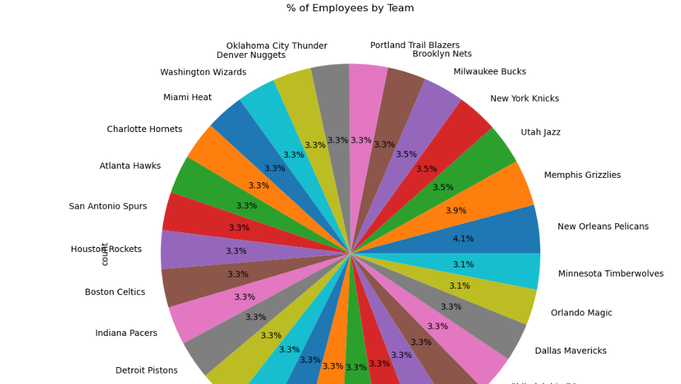

**2.**Segregate employees based on their positions within the company. (2 marks)

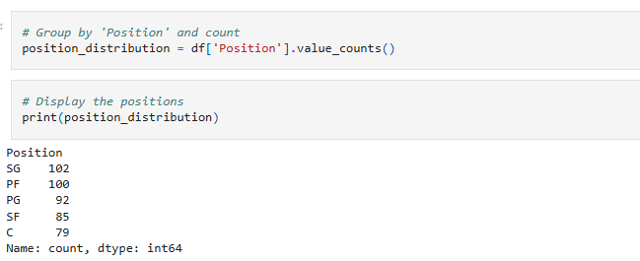

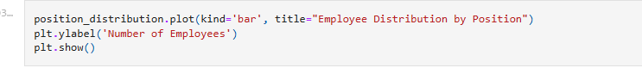

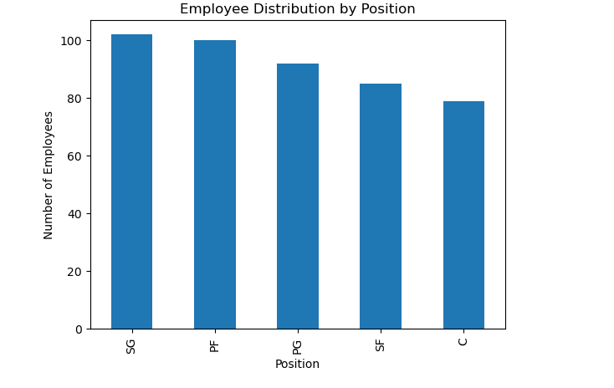

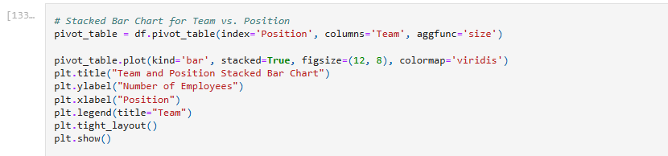

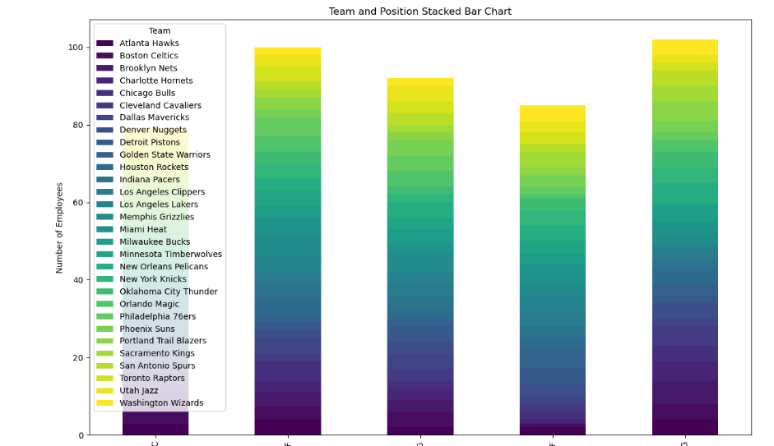

**3.**Identify the predominant age group among employees. (2 marks)

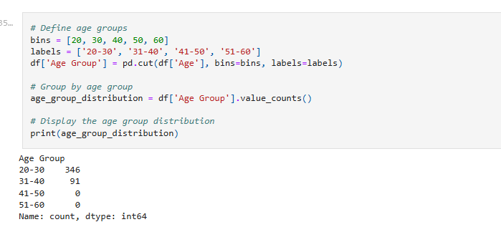

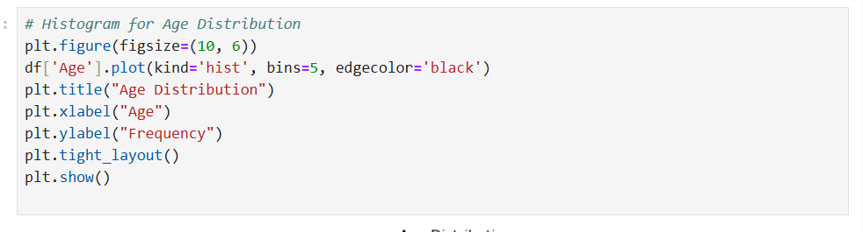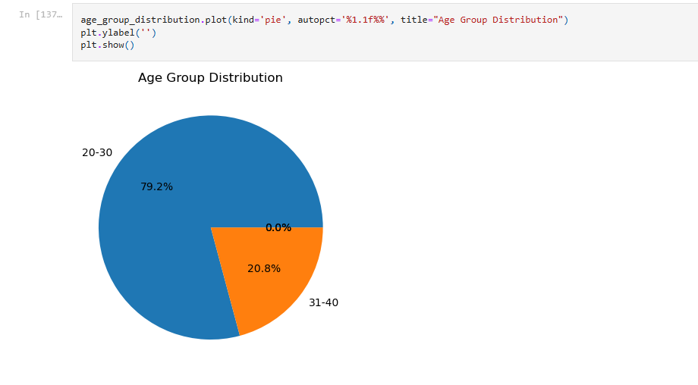

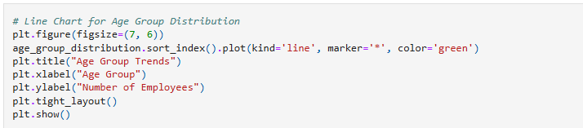

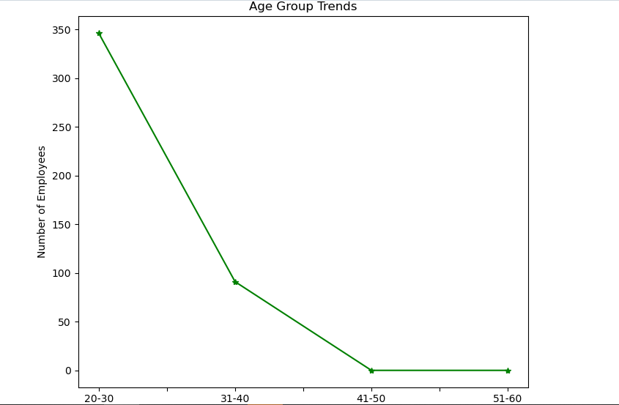

**4.**Discover which team and position have the highest salary expenditure. (2 marks)

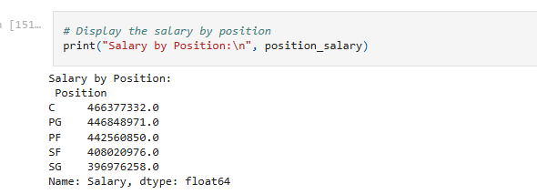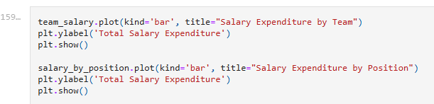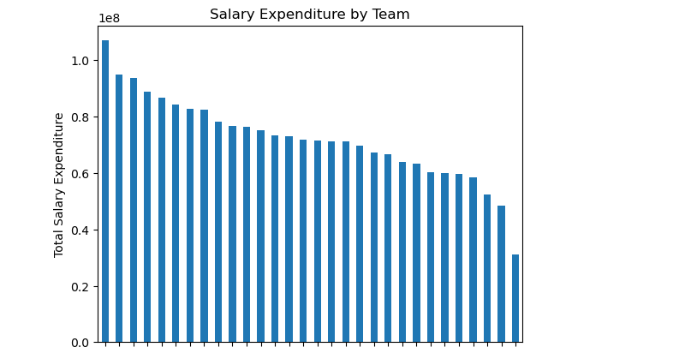

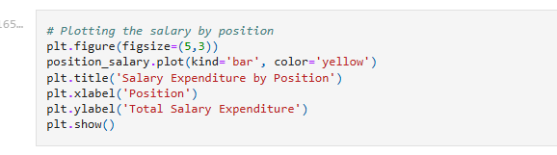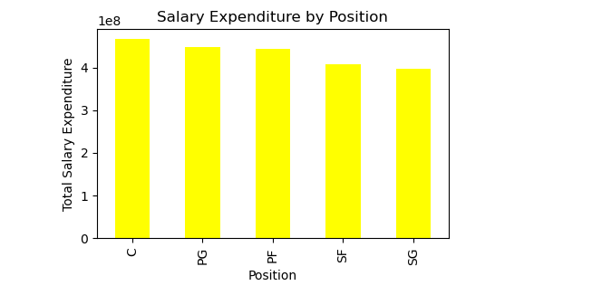

**5.**Investigate if there's any correlation between age and salary, and represent it visually. (2 marks)

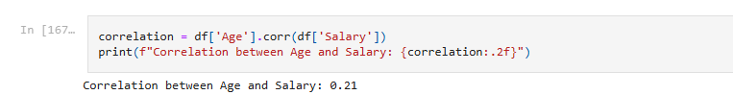

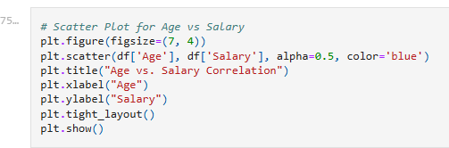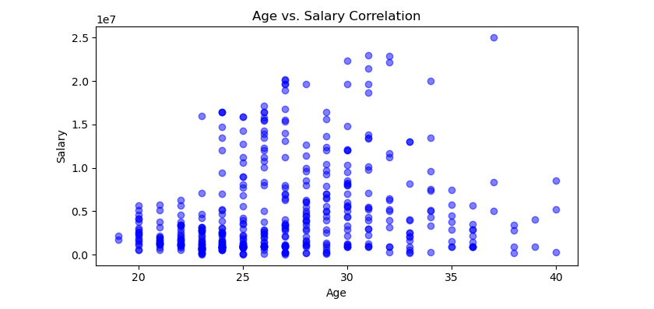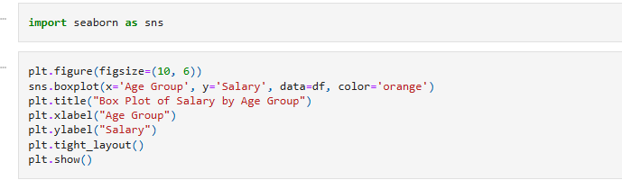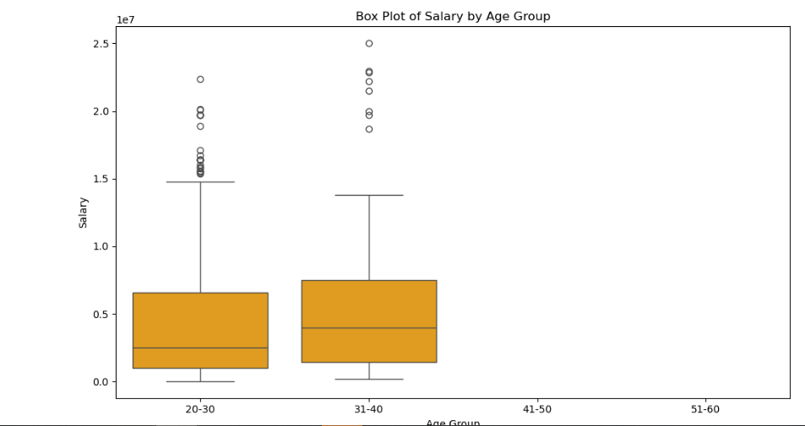

**Data Story Insights on Basketball Players of ABC Company Dataset:**

* **Employee Distribution Across Teams**: The bar chart depicting the distribution of players across teams reveals that a New Orleans Pelicans team followed by Memphis Grizzlies team hold the majority of the workforce. For instance, New Orleans Pelicans has the highest number of players, suggesting it plays a crucial role in the company’s operations.
* **Player Distribution by Position:** The analysis revealed a significant distribution of players across various positions. The number of players for SG (Shooting Guard) is highest with 102 and lowest is position C (Center) with 79 employees.
* **Age Distribution:** The age analysis indicated that the majority of players fall within the 20-30 age range. This is a crucial age group for peak performance, suggesting that teams focus on recruiting younger talent while also investing in the development of players in this age bracket.
* **Salary Trends by Position:** A notable pattern emerged showing that centers tend to have the highest average salaries, likely due to their critical role in both offense and defense.
* **Age and Salary Correlation:** The correlation analysis indicated a moderate positive correlation between age and salary. This suggests that as players age and gain experience, their salaries tend to increase, likely reflecting their performance, marketability, and the experience they bring to their teams.